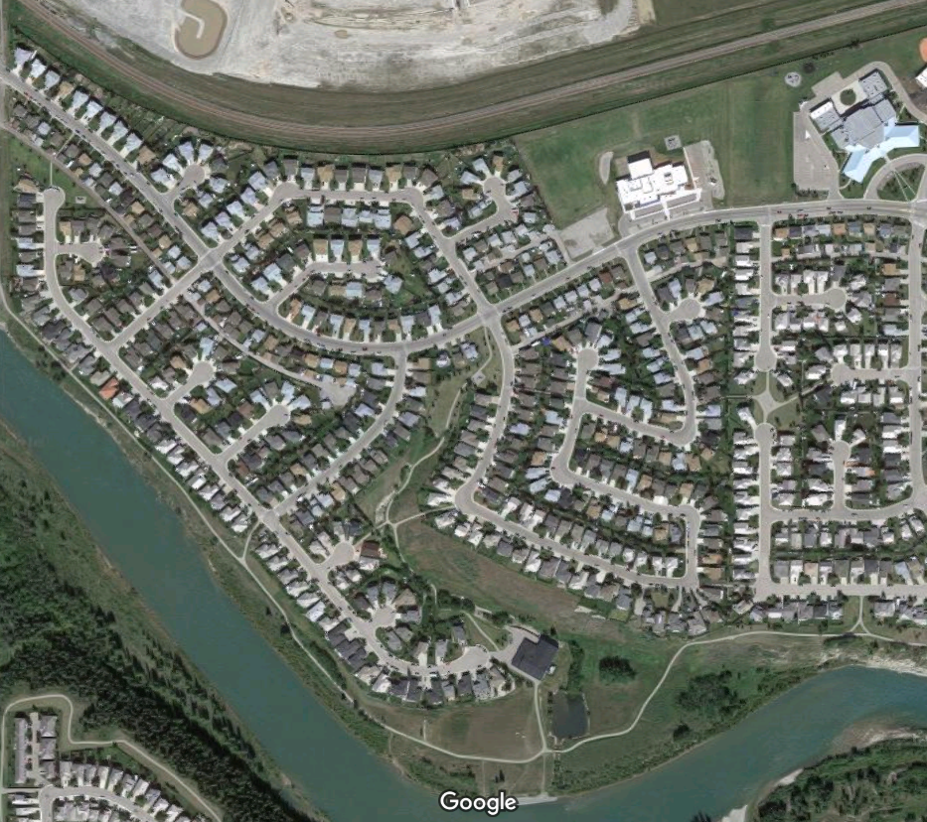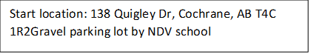

NORTH

To start: orient your map to the North. Align the North side of the map with the train tracks, as it is north from the start triangle. Always keep your map North sign aligned with N.

Start location: 138 Quigley Dr, Cochrane, AB T4C 1R2Gravel parking lot by NDV school