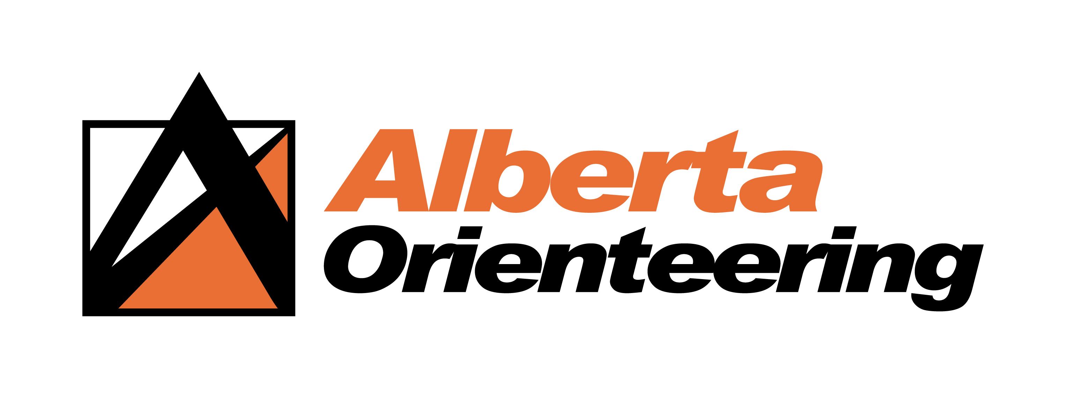
High Performance Grant application

GUIDELINES

Objectives:

Develop a financial granting plan to optimize the development of Alberta orienteers as athletes and leaders in the sport and to raise the profile of the sport.

High Performance Grant: Support the elite athletes (AOA members) who are named by Orienteering Canada to the WOC, JWOC, WUOC, World Cup(s) and World Games National Teams and who also belong to HPP. Also support coaches and team leaders of National Teams who are AOA members.

Definition of Eligibility

- Applicant must be an AOA member in good standing for the current membership year.
- Applicant demonstrates (on application form) evidence of active volunteering (such as coaching, organizing or helping at events, writing article for newsletter, presenting at AOA retreat, writing for HPP blog, etc.) during the 12 months prior to the date of their grant application.

Important General Information
- Grant application deadline is Dec 1 every year.
- Grant amounts: The AOA will be responsible for determining budget amounts available for all 3 grants every year. Funds available for grants are dependent on available funds in any given funding year. Funds distributed through the AOA shall not exceed the budget amounts. Therefore, pro-rating may be required, in which case applicants would not receive the full amount of their eligible funding. Applicants need to understand that AOA cannot guarantee the maximum grant amount, if we decide to pro-rate when budget total is exceeded.
- AOA Board reserves the right to accept or reject applications for any of the 3 grants.
- The decision of the AOA Board is final.

All applications are to be returned by email to: info@orienteeringalberta.ca or to the AOA Office by Dec 1st; all applications received after the deadline will not be considered.

Alberta Orienteering Association
PO Box 1576
Cochrane, AB T4C 1B5

Alberta Orienteering Association

High Performance Grant
APPLICATION FORM

To be completed in full by the athlete and returned to the Alberta Orienteering Association

PERSONAL INFORMATION

Last name: Given name:

Address:

City: |  | Prov.: |  | Postal  Code

Telephone: |  | Email:

No |  | Yes
If you are not originally from Alberta, have you been residing in the province for a minimum of 12 consecutive months?

No |  | Yes
Do you currently live in another province for studying/training purposes?

Are you a member of an Alberta Orienteering Club for the current membership year?
No |  | Yes

Current year-TRAINING INFORMATION
Name of your home club:
(The club you represented during the competitive year)
I am a member of Orienteering Canada HPP | No |  | Yes
I have been named by Orienteering Canada to be on the National Team for: (check all the appropriate ones)  : | WOC
 | JWOC
 | WUOC
 | World Cup
 | World Games
Or to be | National Team Coach
 | National Team Leader

International Competitions

Please provide details regarding the international events in which you have competed in

Current Year- International Competitions

Date  (Month/Year) | Name of the Competition | Location | Results

List evidence of active volunteering (such as coaching, organizing or helping at events, writing article for newsletter, presenting at AOA Retreat, writing for HPP blog etc.) during the 12 months prior to the date of the grant application.
Date  (Month/Year) | Active Volunteering | Location

_____________________________________ ______________________
Applicant’s Signature (or type your name) Date
High Performance Grant criteria

For whom:
  - AOA members who have been named by Orienteering Canada to be on the National team for WOC, JWOC, WUOC, World Cup(s) and World Games and who are also members of Orienteering Canada’s High Performance Program (HPP).
  - AOA members who are a coach or a team leader for a National Team.

Objective: To provide assistance with expenses which are directly related to the championship(s) for which they have been selected, to recognize their efforts as elite athletes or a National Team coach or leader, and to increase their profile in Alberta.

Details about applications for this Grant:
- Applicant satisfies the Definition of Eligibility.
- Applicant may currently live outside Alberta (e.g. for post-secondary education or elite training reasons)
- Applicant must have declared their Alberta Club as their home club, and must represent that club and AOA during the current competitive year.
- Elite athlete applicant must be a member of Orienteering Canada’s HPP.
- Applicant must be named by Orienteering Canada to be on the National team for WOC, JWOC, WUOC, World Cup(s) and/or World Games in the year of the grant, or to be a National Team coach or leader.
- Applicant can submit only one application per year, irrespective of the number of competitions attended in the year.
- Applicant can receive a grant from another source for these competitions.
- Athlete cannot apply for a Pursuit of Athletic Excellence grant for the same event(s).
- Grants will be awarded only after the event(s) have been attended and the athlete’s attendance has been confirmed.
- In the event of injury or illness:
  - If injury/illness prevents an athlete from participating in an event while at the event itself, the athlete will be able to apply for the grant.
  - If the injury/illness happens before the event and the athlete cannot attend the event, the athlete will not be able to apply for the grant.
- Applicant must apply with the correct form.
- Applicant must respect the application deadline. Any application received after the deadline will not be accepted. Information will be emailed to AOA members as a reminder, and will also be posted on AOA’s website.
- Grant amount: maximum of $500 per applicant. If the budget total is exceeded, the grant amounts will be pro-rated.

