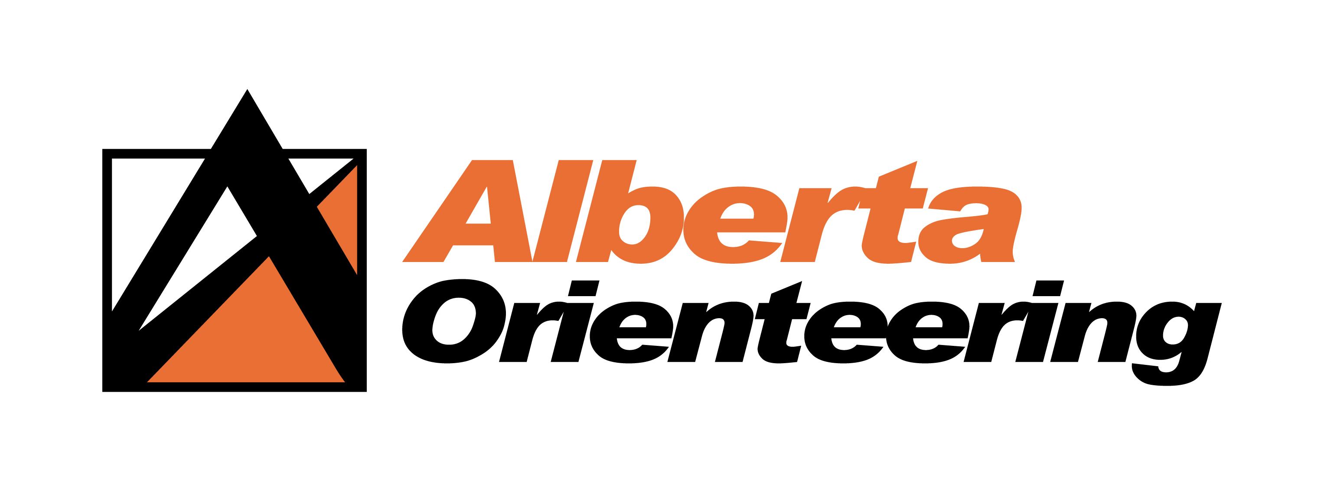
PROXY VOTE
2024 ANNUAL GENERAL MEETING

Club Name:__________________
I, __________ being a member of the Alberta Orienteering Association
(Member Name)
and entitled to attend and vote hereby appoint _____________________
(Proxy Holder)
as my proxy to act generally at the meeting on my behalf and to vote in accordance with the following directions (or if no directions have been given, as the proxy sees fit) at the Annual General Meeting of the Alberta Orienteering Association, to be held on April 4, 2024 6:30 pm in Alberta utilizing online conference system.
Member’s email: _____________________
Member’s signature: ___________________
(Typing your full name is accepted).
NOTE:
No member may hold more than two (2) proxies, and will notify
AOA before the General Meeting of any proxies held.
Proxy can also been sent by email at: info@orienteeringalberta.ca
(Picture file or PDF of the completed form is acceptable.)

